**Task 1: Connect to Excel – Multiple Tables**

Task 1. Load the following Excel files using *Get Data > Excel Workbook*:

* AdventureWorksSales2015.xlsx
* AdventureWorksSales2016.xlsx
* AdventureWorksSales2017.xlsx

Rename the files as :

Sales2015, Sales2016, Sales2017

**Task 2: Load Options**

* First load AdventureWorksReturns.xlsx directly using **Load**.
* Then import AdventureWorksReturns.xlsx again using **Transform Data**, clean it (e.g., remove nulls), and then load.

**Task 3: Merge Queries**

* Merge Sales2017 with Customers on CustomerID.  
    
  + Use a *Left Outer Join*.
  + Expand only CustomerName, Email.

Task 1. Load the following Excel files using *Get Data > Excel Workbook*:

* AdventureWorksSales2015.xlsx
* AdventureWorksSales2016.xlsx

AdventureWorksSales2017.xlsx  
  
  
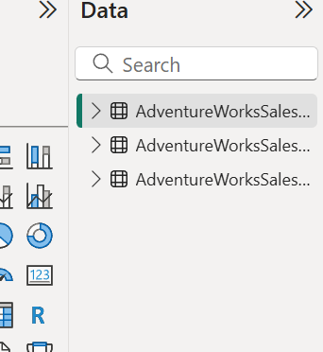  
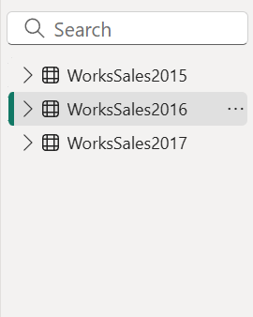

**Task 2: Load Options**

* First load AdventureWorksReturns.xlsx directly using **Load**.
* Then import AdventureWorksReturns.xlsx again using **Transform Data**, clean it (e.g., remove nulls), and then load.

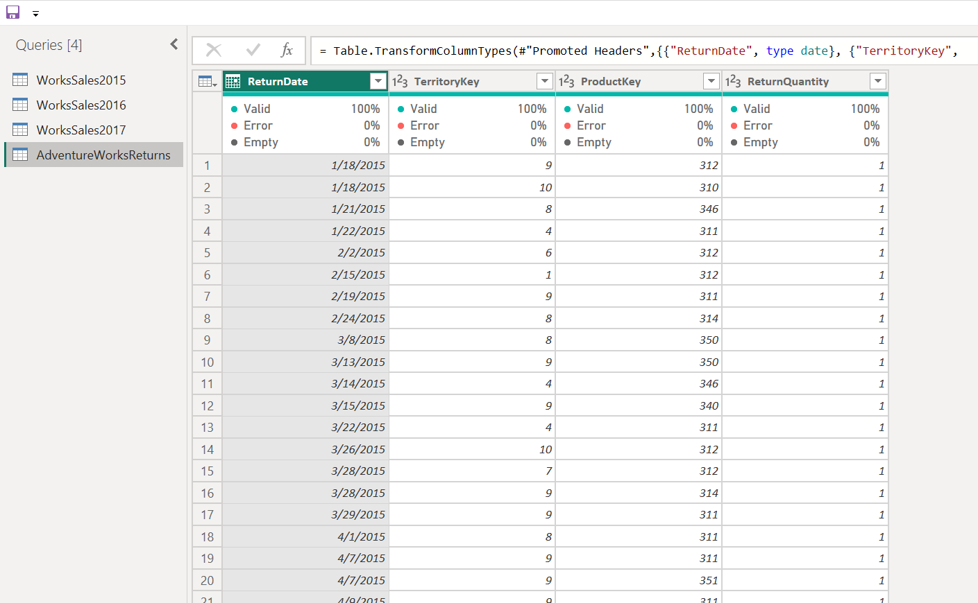

**Task 3: Merge Queries**

* Merge Sales2017 with Customers on CustomerID.  
    
  + Use a *Left Outer Join*.
  + Expand only CustomerName, Email.

